Guideline on Wrong Way Risk Margin Add-on
Last update: 2026-06-22

Scope of this guideline

This guideline covers the Wrong Way Risk (WWR) Margin Add-on methodology applied by Nasdaq Clearing to capture WWR in cleared derivatives positions. A WWR Margin Add-on is applied to mitigate the risk that the exposure in cleared positions could increase in parallel with the deterioration of the credit worthiness of the clearing member holding those cleared positions.

The WWR Margin Add-on applies to all equity derivatives except index products. For F/I derivatives there is currently no WWR Margin Add-on. The WWR Margin Add-on covers only direct issuer/counterparty WWR, no general WWR such as industry/sector or geographic region WWR.

Purpose and objective of WWR MArgin Add-on

Nasdaq Clearing’s margin methodologies are not designed to capture additional risk for cleared positions stemming from WWR as there is no factor in the methodologies that evaluates the issuer of a contract (or rather the issuer of the instrument or security that is underlying a contract) vs the holder of cleared positions in that contract. Therefore, a WWR Margin Add-on is added to the initial margin requirement to capture the risk that close-out of positions subject to WWR will be costlier than calculated by the base methodology, or that positions could not be closed-out at all due to WWR.

The WWR Margin Add-on outlined in this guideline is designed to disincentivize positions subject to WWR and to capture the additional default or close-out costs due to WWR in individual Clearing Members’ portfolios. The WWR Margin Add-on applied will differ in between asset classes, but in general it applies to net long positions in own issue instruments for both House and Client positions.

For Equity derivatives will WWR Margin Add-on be based on the assumption that the price of own issue stocks becomes 0. Own issue stock includes any listed stock issued by the clearing member or an entity within the same legal group as the clearing member. The WWR Margin Add-on applies to all equity derivatives except index products.

WWR Margin Add-on methodology

For equity derivatives the WWR Margin Add-on is determined per Margin Calculation Account (MCA) in the following three main steps, with the considerations for each step outlined below:
- Check if the position is applicable for WWR.
  - If yes then re-value the position at the WWR Price Scenario.
    - If the margin at the WWR Price Scenario is higher (more negative) than the margin as calculated by the base methodology then this is the new margin and the WWR Margin Add-on is the difference. The WWR Margin Add-on is distributed pro-rata back to the contract level positions based on the risk margin (IM) in the WWR Price Ccenario.

After the MCA margin calculation has been completed the results are aggregated to higher levels (i.e. Margin Requirement Account, MRA) using the existing margin aggregation rules.

Step 1 – A position is eligible for WWR

A position is defined as all positions (futures, forwards, different types options and delivery positions) on the same underlying single stock within a Margin Calculation Account (MCA). The possibility to build a position in an underlying stock using different kinds of derivatives means that the total (or net) exposure to the stock needs to be taken into account. This includes also delivery positions which are created during the time between expiration and settlement for physically settled contracts. It also includes exposures to a stock obtained through positions in customized stock basket forward (Custom Basket Forward, “CBF”) contracts. However if the underlying is an index then the position is not applicable for WWR Margin Add-on.

Client accounts lacking porting arrangement also qualify for WWR Margin Add-on.

Finally the applicability for WWR includes to check the relationship between issuer of the stock and the clearing member holding the position; if the entity issuing the stock belongs to the same legal group as the clearing member then it is applicable for WWR Margin Add-on.

Step 1.a. – WWR Price Scenario
In step 1.a. the position is re-valued at the WWR Price Scenario. The WWR Price Scenario is at present set to 0, but it is considered to set it to a higher value as a future model development.
For the case with WWR Price Scenario = 0 there are a few deviations from the base methodology with respect to the re-valuation calculation. The reason for this is that the base methodology aims to determine the close-out cost of a derivative, while in the WWR Price Scenario = 0 case the assumption is that there is no longer a functioning market for the stock and for derivatives on that stock, i. close-out is not applicable. These deviations are listed below.
- Forward and future prices are set to 0
- Adjustment for forward/future bid/ask spread is not applied
- Option fine tuning (bid/ask spread, reduction in time value held options, etc) is not applied
For the case with WWR price scenario > 0 a close-out is assumed and the re-valuation at the WWR Price Scenario is made using the base methodology.
Step 1.a.i – WWR Margin Add-on distribution
The WWR Margin Add-on calculated in step 1.a.i. is distributed pro-rata back to the contract level positions based on the risk margin (IM) in the WWR Price Scenario. The sum of the WWR Margin Add-on for the contract level positions thus equals the total WWR Margin Add-on for an MCA. Any contract level position having a positive risk margin (i.e. making a gain) in the WWR price scenario will not get any WWR Margin Add-on distributed to it. An example illustrating the distribution methodology is provided below.

Additional considerations

If a position is applicable for both Concentration Margin Add-on and WWR Margin Add-on then only the higher (most negative) of the two will apply.

For CBFs the WWR Price Scenario will be determined through re-pricing the basket with the applicable basket constituent’s price set to 0.

Application of WWR MArgin Add-on
WWR Margin Add-on is included in all margin calculations (both Intra-day and End-of-day) and in margin simulations.
The WWR Margin Add-on is determined per MCA and presented per MCA and instrument level position in the Positions report. The WWR margin add-on is included in the Required Initial Margin, Payment/Delivery Margin (if WWR is applicable for a delivery position), Naked Margin and Required Margin values. The WWR Margin Add-on is separately reported for information in the new Wrong Way Risk Add-on column.
Single position example
The below example on two fictive accounts SE A 1 (long position in own issue stock through a forward trade) and SE A 2 (short position in own issue stock through a forward trade) shows that a WWR Margin Add-on is charged for account SE A 1. The WWR Margin Add-on is separately reported for information in the Wrong Way Risk Add-on column.
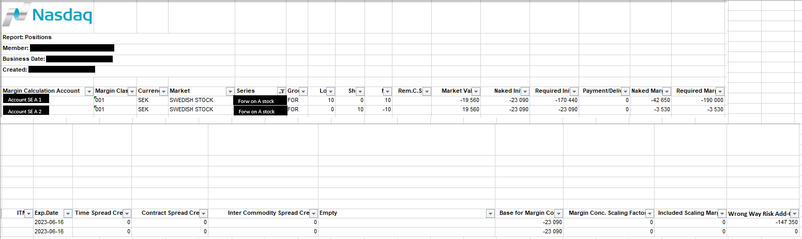
A margin simulation of account SE A 1 gives these results.
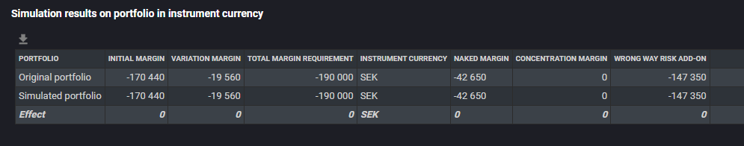

Portfolio example
The WWR Price Scenario in the below OMS2 vector files are in red text and having scenario number 31. In the actual model implementation in Genium INET there is a different internal handling (there will be no scenario number 31) and the external vector files for OMS2 replication will not include the WWR Price Scenario.
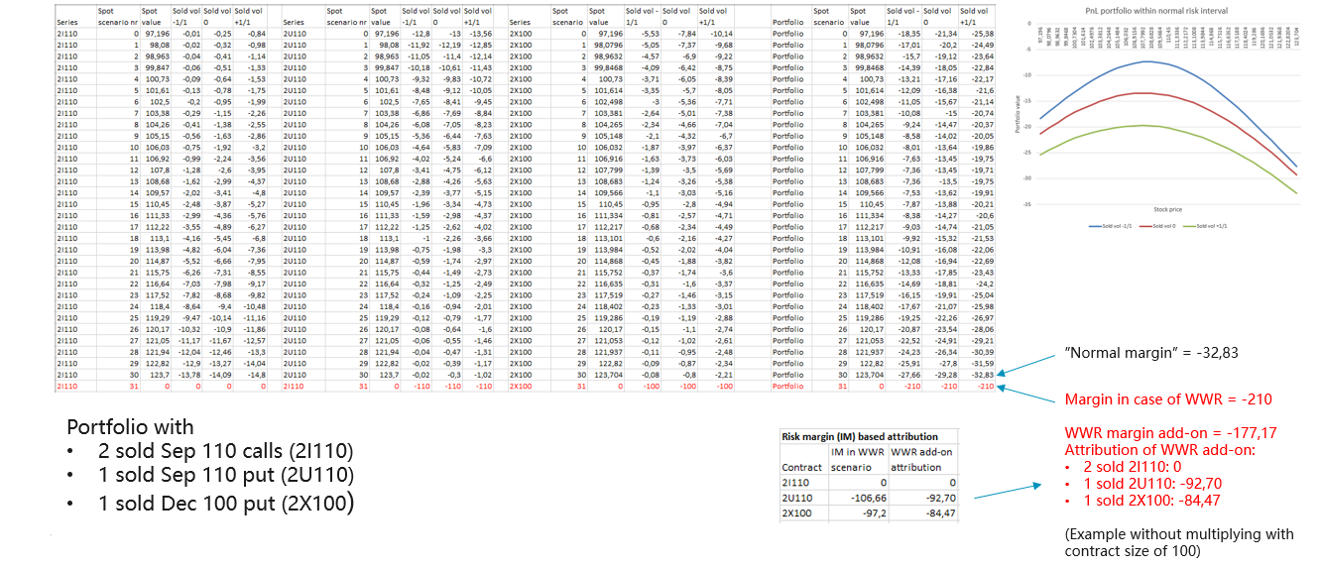

Contact information
If you have any questions or require any additional guidance, please contact Nasdaq Clearing Risk Management.
Risk Management: clearing.risk@nasdaq.com
Sweden: +46 8 405 7088
Norway: +47 67 10 84 26

